# Lecture 19. Elasticity & Scalability 101 8:48

1. Elasticity: Scale Out (Increase number) - Easy to Scale Out and Scale Back
2. Scaling: Scale-Up (Increase Size) – Easy to Scale Up, But not easy to Scale Down

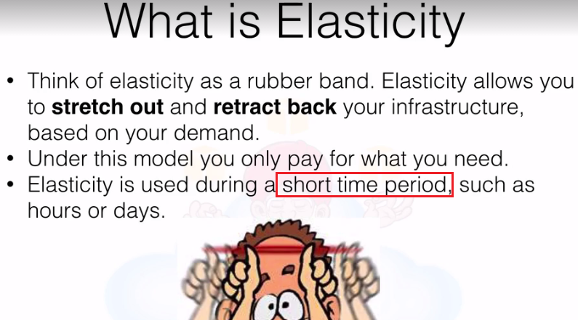

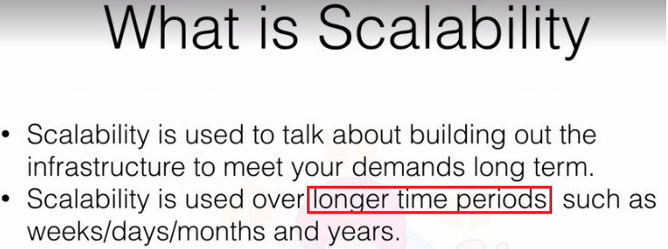

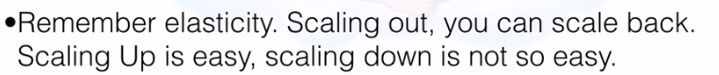

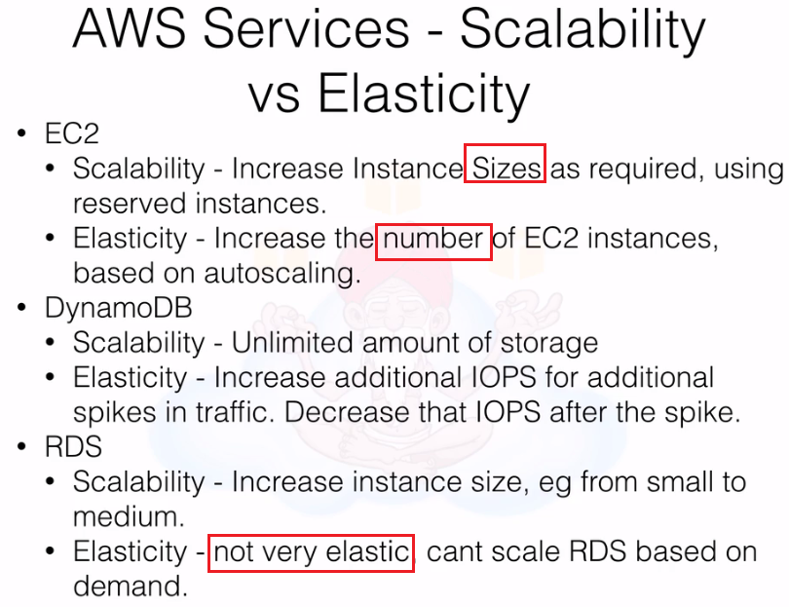

# Lecture 20. Scale Up or Scale Out? 10:40

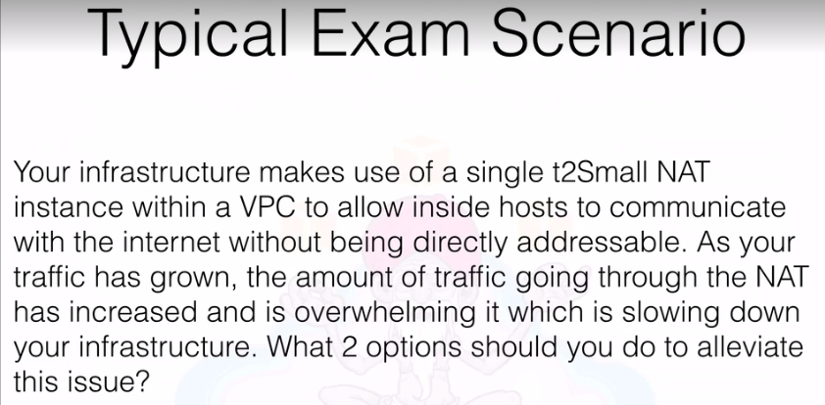

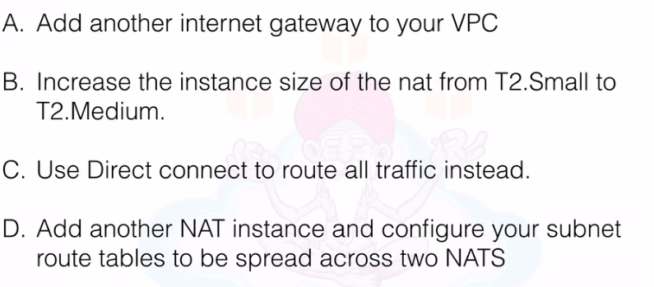

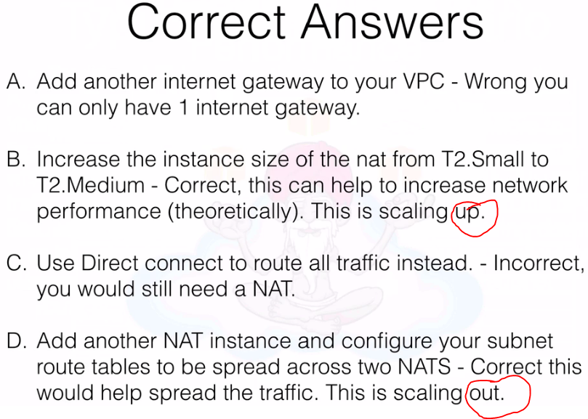

# Lecture 21. RDS and Multi-AZ Failover 4:37

1. Multi-AZ – Is for Disaster Recovery Only
2. Read Replica – If for Performance Gain or Scaling

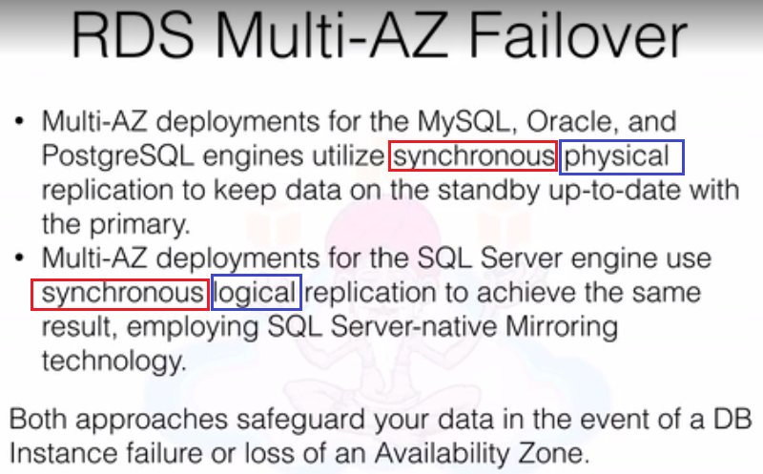

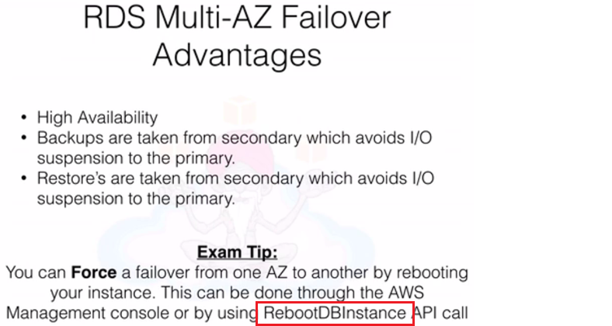

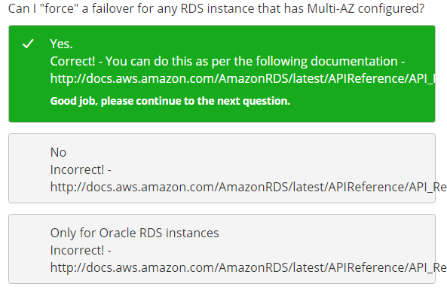

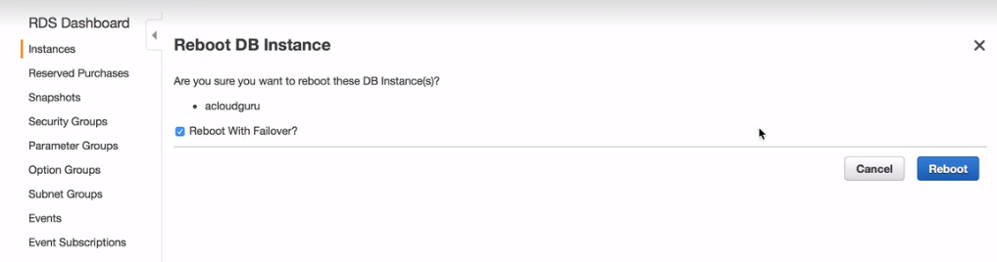

# Lecture 22. RDS & Using Read Replica's 12:48

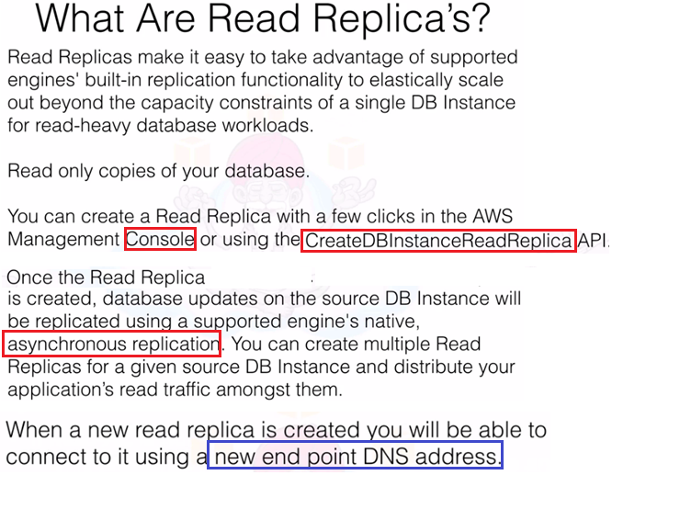

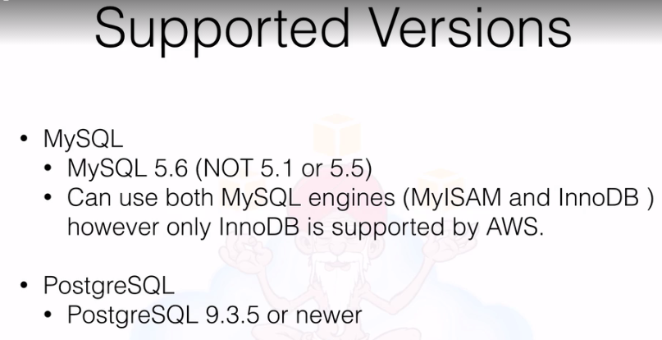

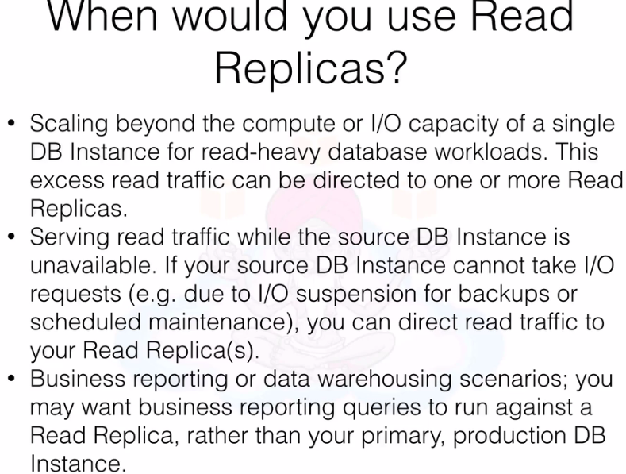

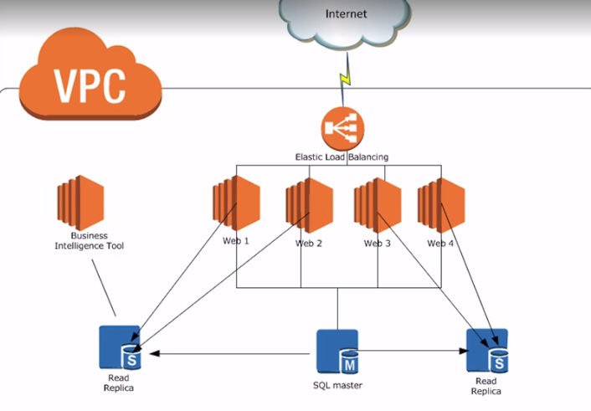

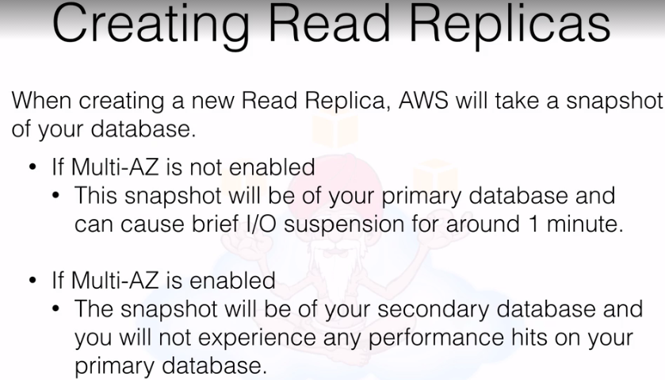

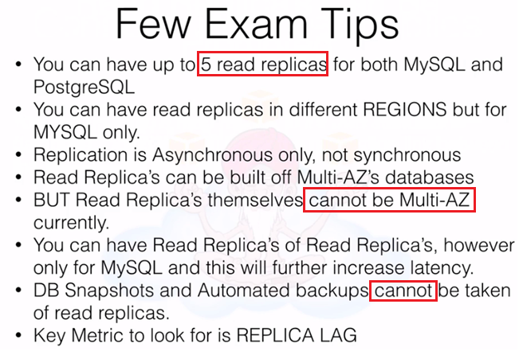

* Database ‘Automated Backup’ must be enabled in order to create ‘Read Replicas’. Or you must have a DB snapshot created.
* To create Read Replicas of Read Replicas, you need enable Automated Backup on Read-Replicas

# Lecture 23. RDS Multi-AZ & Read Replica's Lab 19:36

# Lecture 24. Using Bastion Hosts and High Availability 4:32

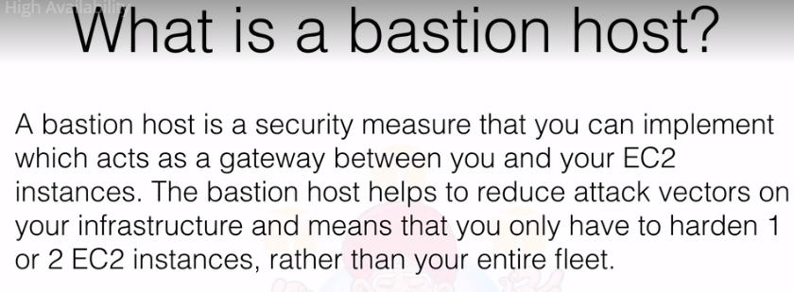

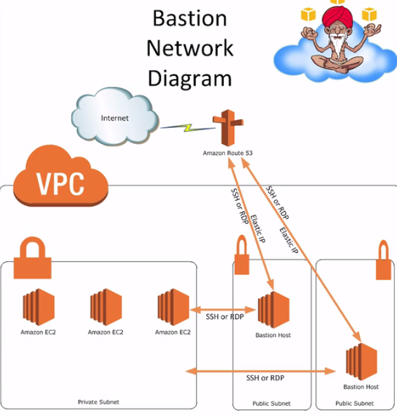

# Lecture 25. Troubleshooting & Potential Auto Scaling Issues 3:22

